**Human Resource Management (HRM) Panel** **Cleveland State University**

**User Manual**

Version 1.0

Ahmad Alomari

Dipen R Bhuva

Ryhan Uddin

**Table of Contents**

1.0 Introduction 2

2.0 Home Page 2

3.0 Overview of the Pages 2

3.1 Home: 3

3.2 Programs: 3

3.2.1 Professional Development: 4

3.2.2 Leadership Training: 8

3.2.3 Team Development: 9

3.3 Contact Us: 10

3.4 Job benefits: 11

3.5 HR Partners: 13

3.6 Career: 15

3.7 About: 16

3.8 HR Sign in: 18

4.0 Accessing the Admin Panel 18

5.0 Dashboard Overview (Human Resource Management (HRM) Users) 19

5.1 Professional Development Interface (End Users or Employees) 21

5.2 Leadership Training Module (End Users or Employees) 22

5.3 Team Development Tools (End Users or Employees) 22

5.4 Careers Portal (End Users or Employees) 22

5.5 Managing Employee Data 22

**Performance Evaluation and Management** 23

5.6 Talent Acquisition and Onboarding 23

5.7 Payroll and Benefits Management 23

5.8 Compliance and Legal 23

5.9 Troubleshooting and Support 23

6.0 Conclusion 24

# 1.0 Introduction

Welcome to the Human Resource Management (HRM) Panel at Cleveland State University. This manual will guide you through the functionalities of the HRM Panel, designed to streamline HR processes, enhance employee management, and facilitate professional development and career advancement at the university.

# 2.0 Home Page

Link: <https://tinyurl.com/csuohiohrm>

The above link will redirect you to the main page of the HRM panel which is hosted through a free hosting (url: <http://northeastern.rf.gd/>). It offers a very simple interface showcasing various tabs for users to navigate. The main page looks like following.

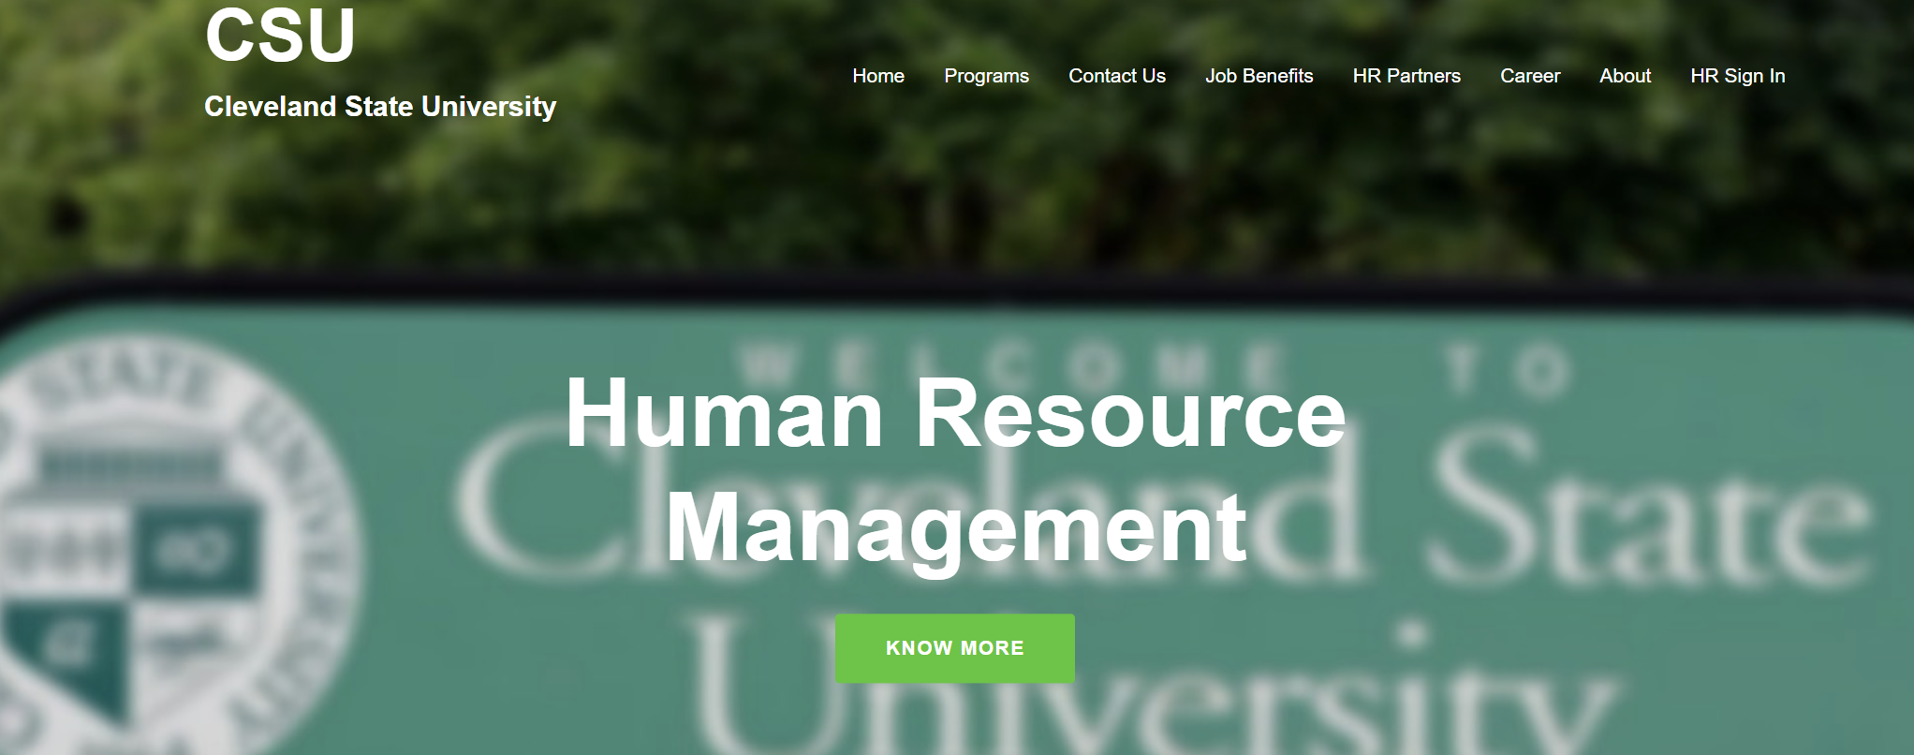

# 3.0 Overview of the Pages

The panel contains following pages that can be navigated seamlessly through different tabs on the panel.

## **3.1 Home:**

This is the landing page of the panel where users will once the website loading is finished. You can land on the home page also by clicking on the banner. The home has all the primary tabs that can help you to navigate to different pages by clicking on them.

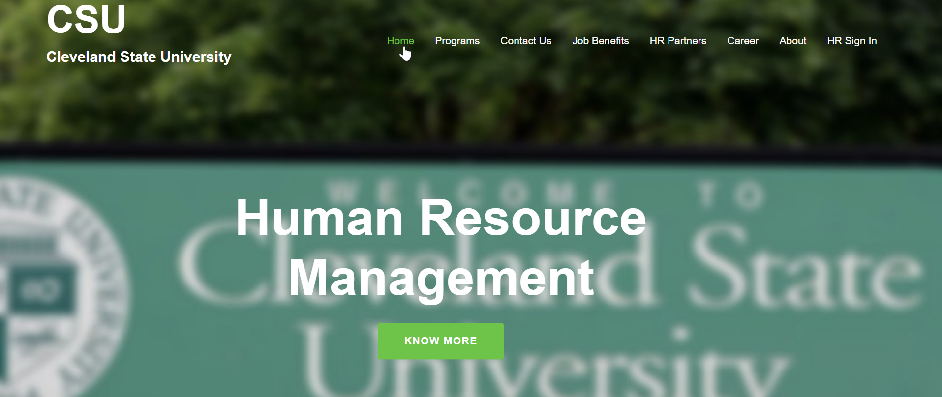

## **3.2 Programs:**

The programs tab will land you on the programs page that contains all the created programs. If you hover the programs tab it will open a drop down menu showing sub-categories of pages named professional Development, Leadership Training and Team Development pages. You can navigate to those pages through this drop down menu. Following figure shows the snippet of the programs tab.

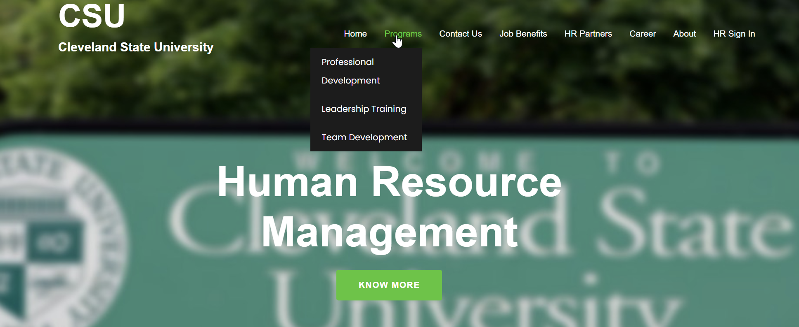

The programs tab contains following sub-pages which offers various programs catered towards specific users. If you are a member of the HR team, you can find your required program that can satisfy your career goals. Followings are the summary which will help you get an overview of the related programs that are offered though the sub-pages.

### **3.2.1 Professional Development:**

It boasts a user-friendly interface for employees to access professional development opportunities. It has full Integration with event calendars to promote and track training sessions, workshops, and seminars. It also offers online registration and tracking of employee participation in professional development programs. You (as an employee) can access training materials and resources for ongoing professional development. Following figure given an overview of the page.

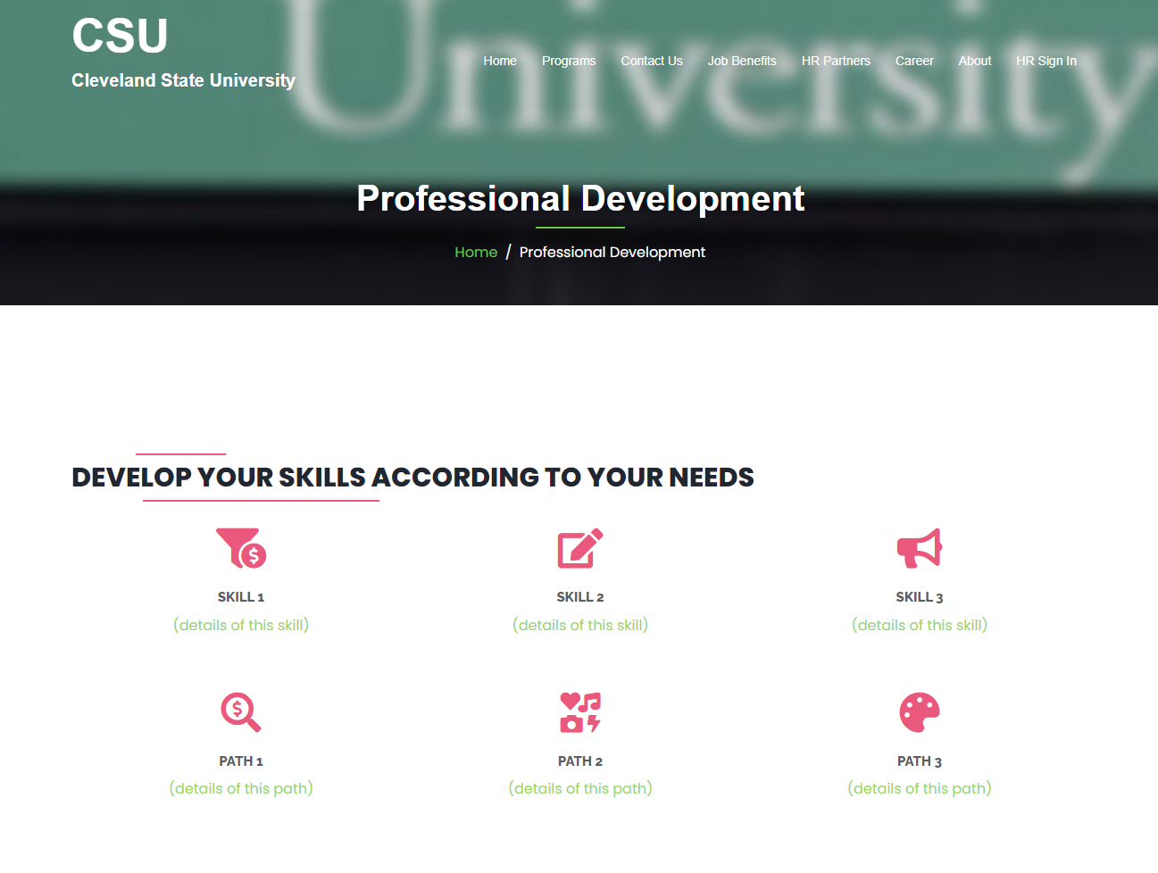

In the bottom of the page you can find an icon that provides the ability to access the course link as long you are enrolled as an employee. Following figure shows the process.

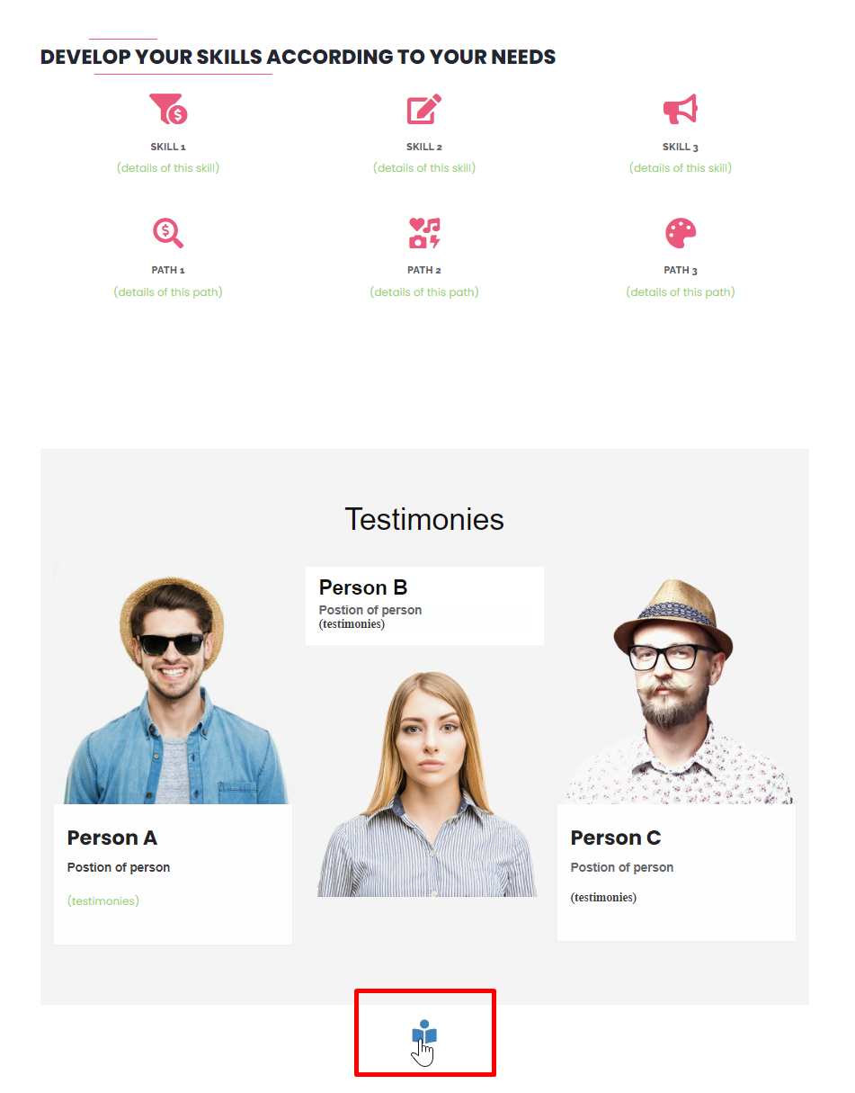

Once the icon is pressed it will be redirected to a new page that contains the related course information. This login / access pattern can be seen in other tabs as well.

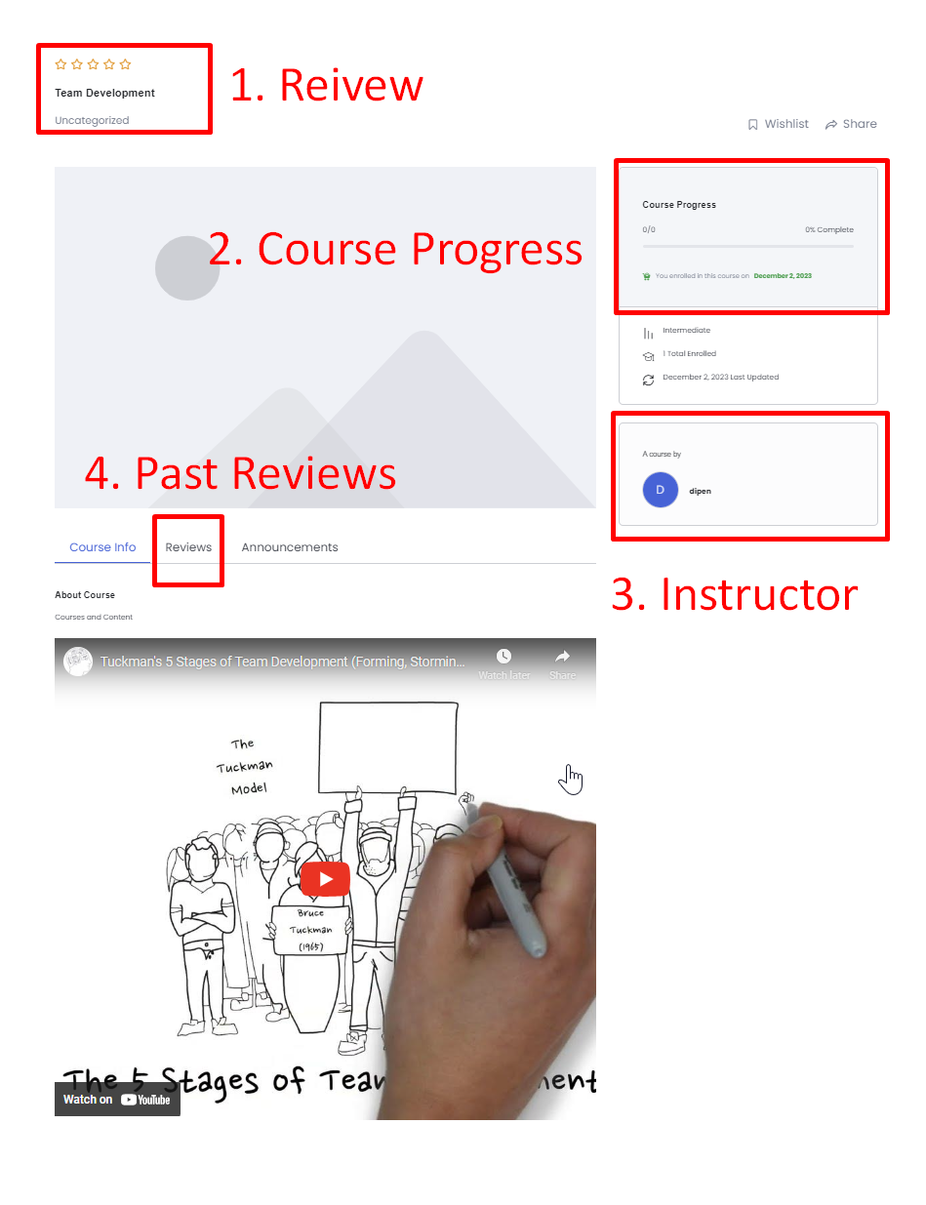

As seen in the screenshot above, each program tabs contain sections to provide your review (highlight 1), course progress, details of the course and the instructor and past reviews to assess the past course takers experience. Last and most import segment is the content itself, which can be online course module (video format) or can be static and dynamic page shuffling contents where you can navigate pages by clicking next buttons. However, for the time being we have only provided example for video content.

### 3.2.2 Leadership Training:

You can access to leadership training resources and materials by navigating the Leadership Training tab. It provides Interactive modules for leadership skill development. Following screenshot provides an overview of the page with various available courses to choose from.

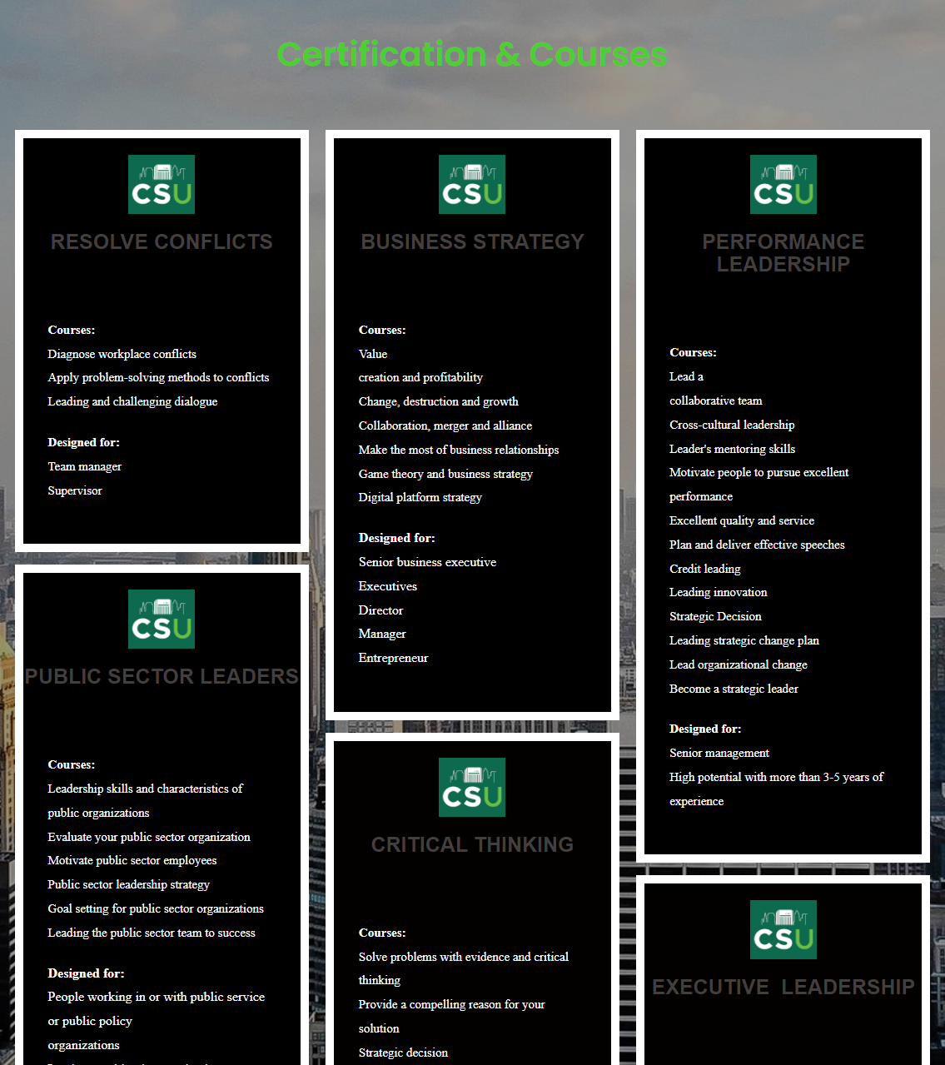

### 3.2.3 Team Development:

The team development tab offers access to team-building resources and activities through collaboration tools for teams within the university. It also has integration with HR processes to support team development initiatives. Moreover, if you are a HR manager, or a program leader you can monitor the progress of their team members and provide necessary support. Following page shows the overview of the page.

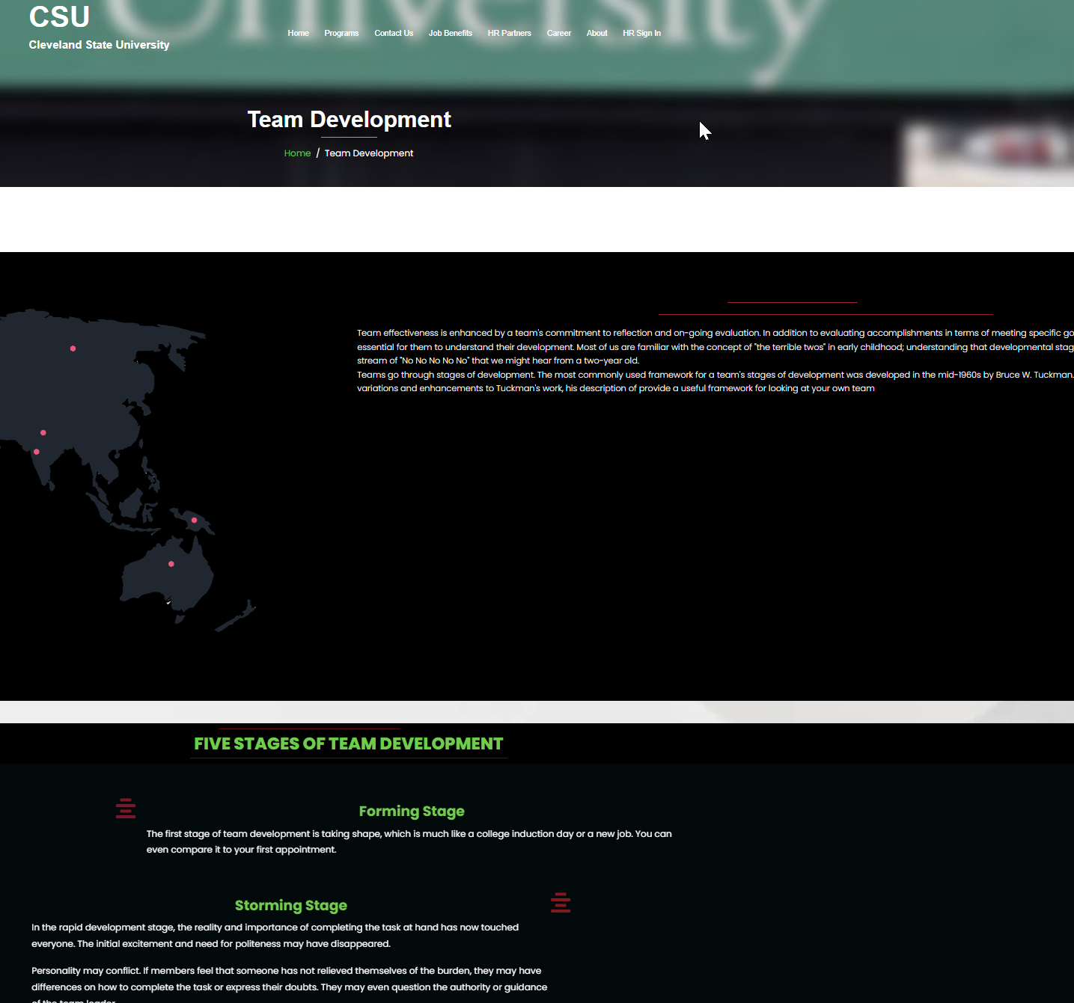

Also in the following figure you can see that it offers the details of programs including the schedules, team details, instructor details and much more.

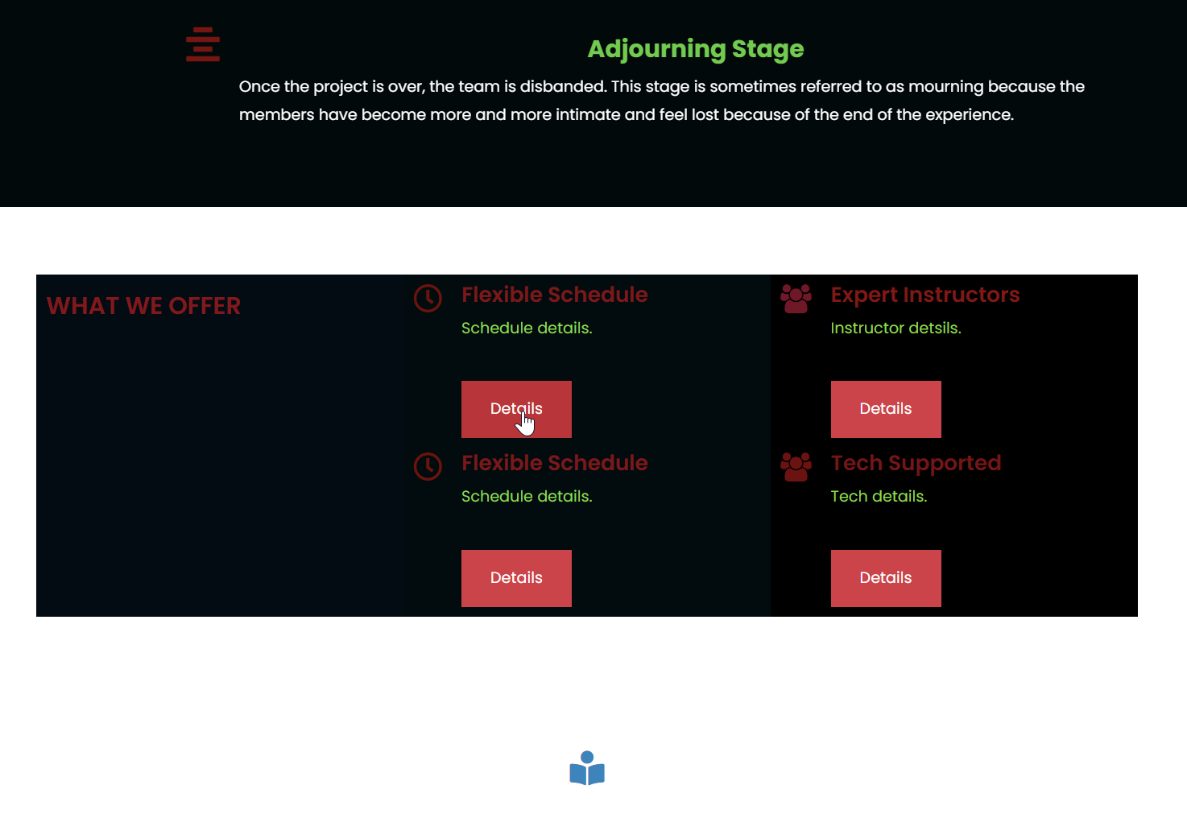

## **3.3 Contact Us:**

The contact us page will take you to the contacts page where you can contact panel admin for assistance. You can connect with the admin through various means such as email the admin, make phone call or you can find various solutions in the FAQs page where the most frequently asked questions are answered. The page also contains the address of Cleveland State University and a form to send custom message to the panel admins.

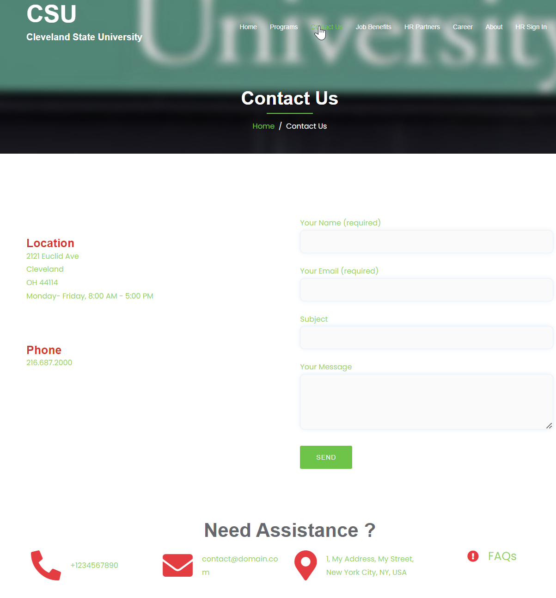

## **3.4 Job benefits:**

Thebenefits tab offers access to comprehensive employee benefits information. It acts as a hub forOnline enrollment and management of benefits programs. It contains Information on medical plans, dental plans, reimbursement accounts, retirement plans, life insurance, disability programs, and tuition reimbursement. As an employee, you can easily access and manage your comprehensive benefits information, and as an HR manager you can view existing policies which are modifiable from the HR manager panel. You can also have access to information on compensation policies and structures, salary range details and performance appraisal programs etc. Following image shows the Job Benefits tab and followed by various plans offered by Cleveland State University that can be updated and modified by HR manager and admin.

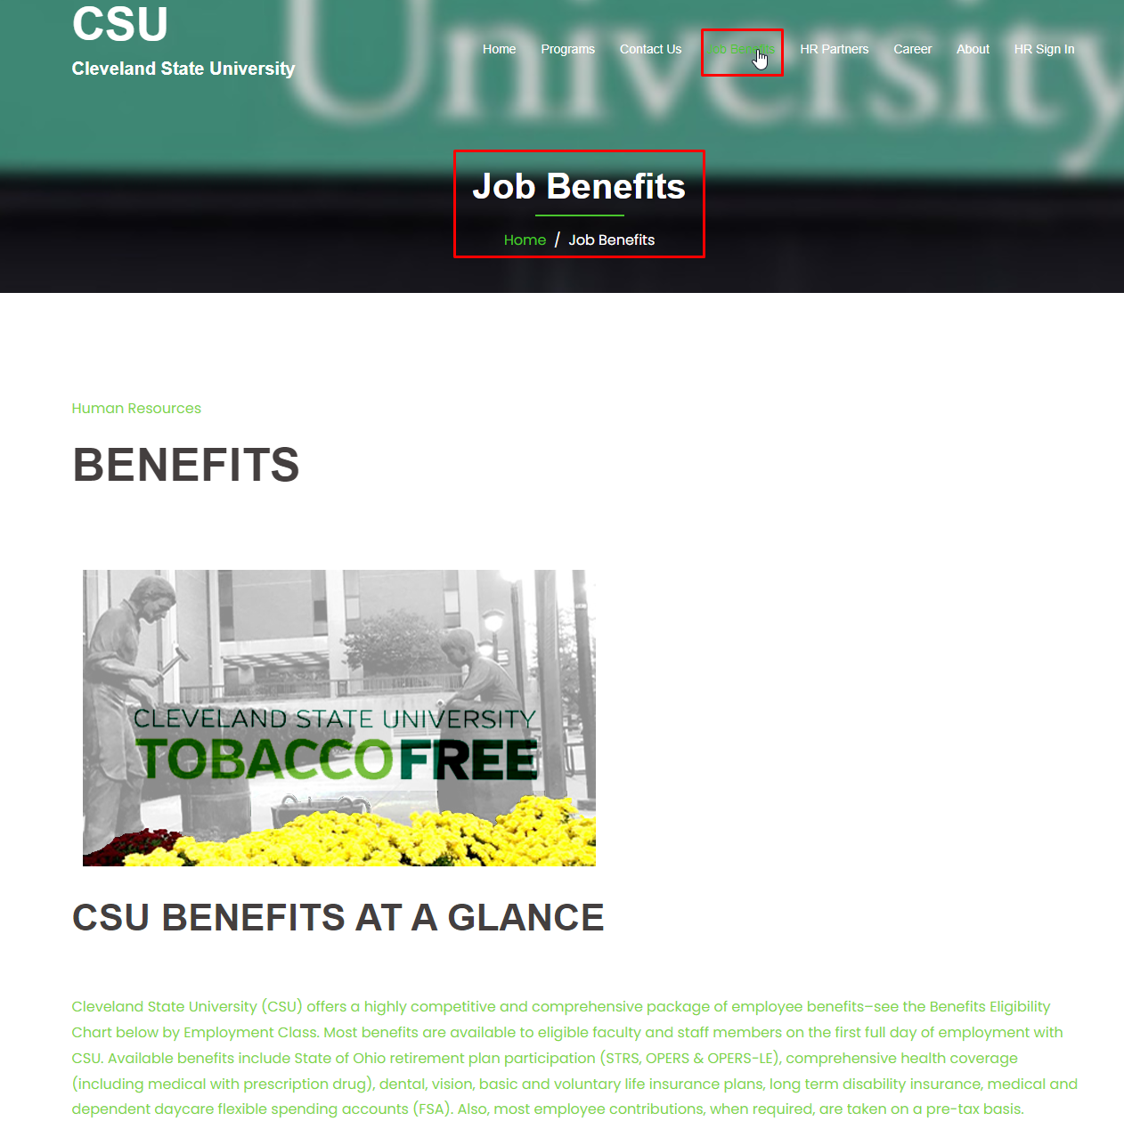

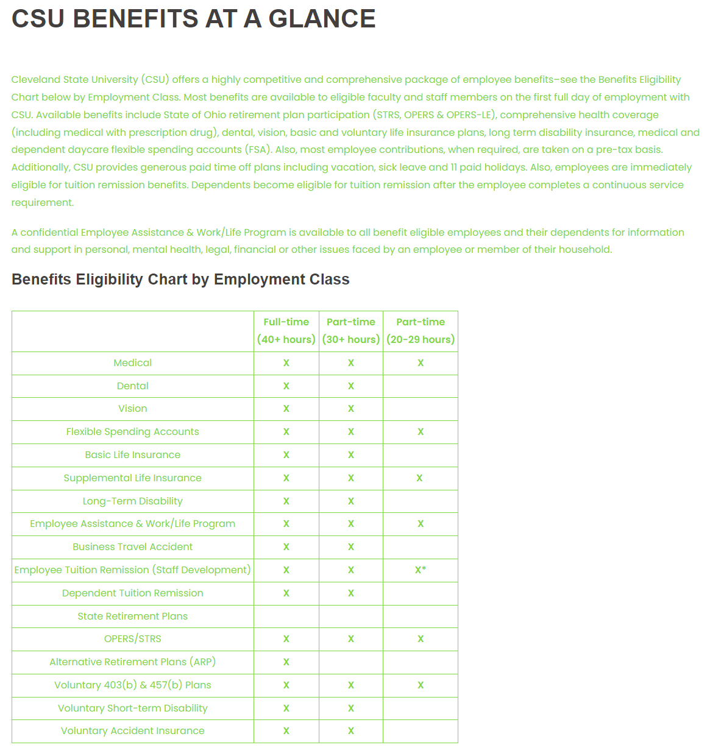

## **3.5** HR Partners:

The HR partners page provides information on HR Business Partners and Talent Acquisition Partners. Services related to change management, organizational design, employee engagement, strategic workforce planning, and performance management etc. can be acquired from this page.

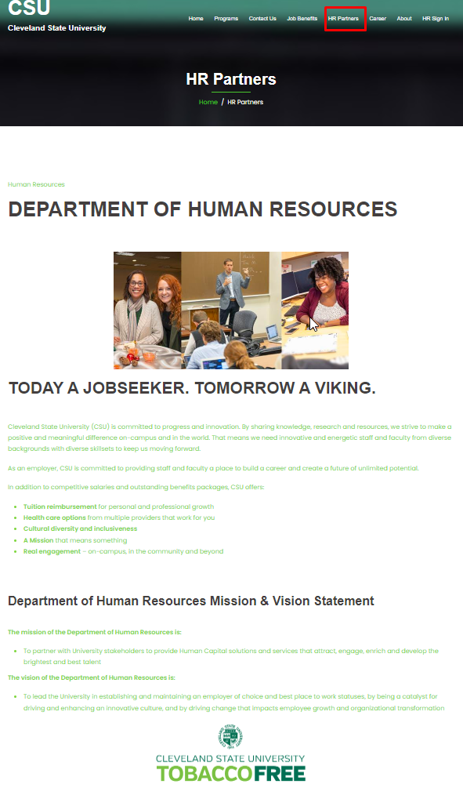

## **3.6 Career:**

The career portal offers a job posting and application functionality for career opportunities within the university. It displays two buttons one for faculty job applications and another for staff job applications. Currently, these buttons are redirecting to the official CSU job portal whereas user you can look for job opportunities based on your position requirements (for both employees and guests alike). However, in future we would like expand the segment by integrating interactive menu without any redirections that will allow users to perform resume submission and application tracking which will also boast seamless integration with HR processes for efficient hiring. Followings images shows the pages.

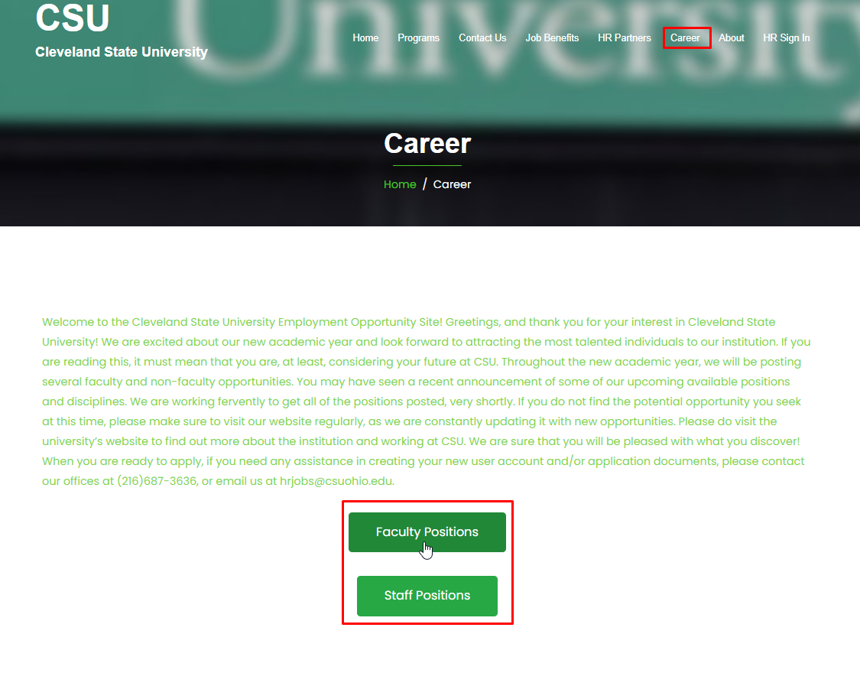

Clicking the buttons will redirect you to the following pages. First one for the search of existing faculty positions and the other one for staff positions.

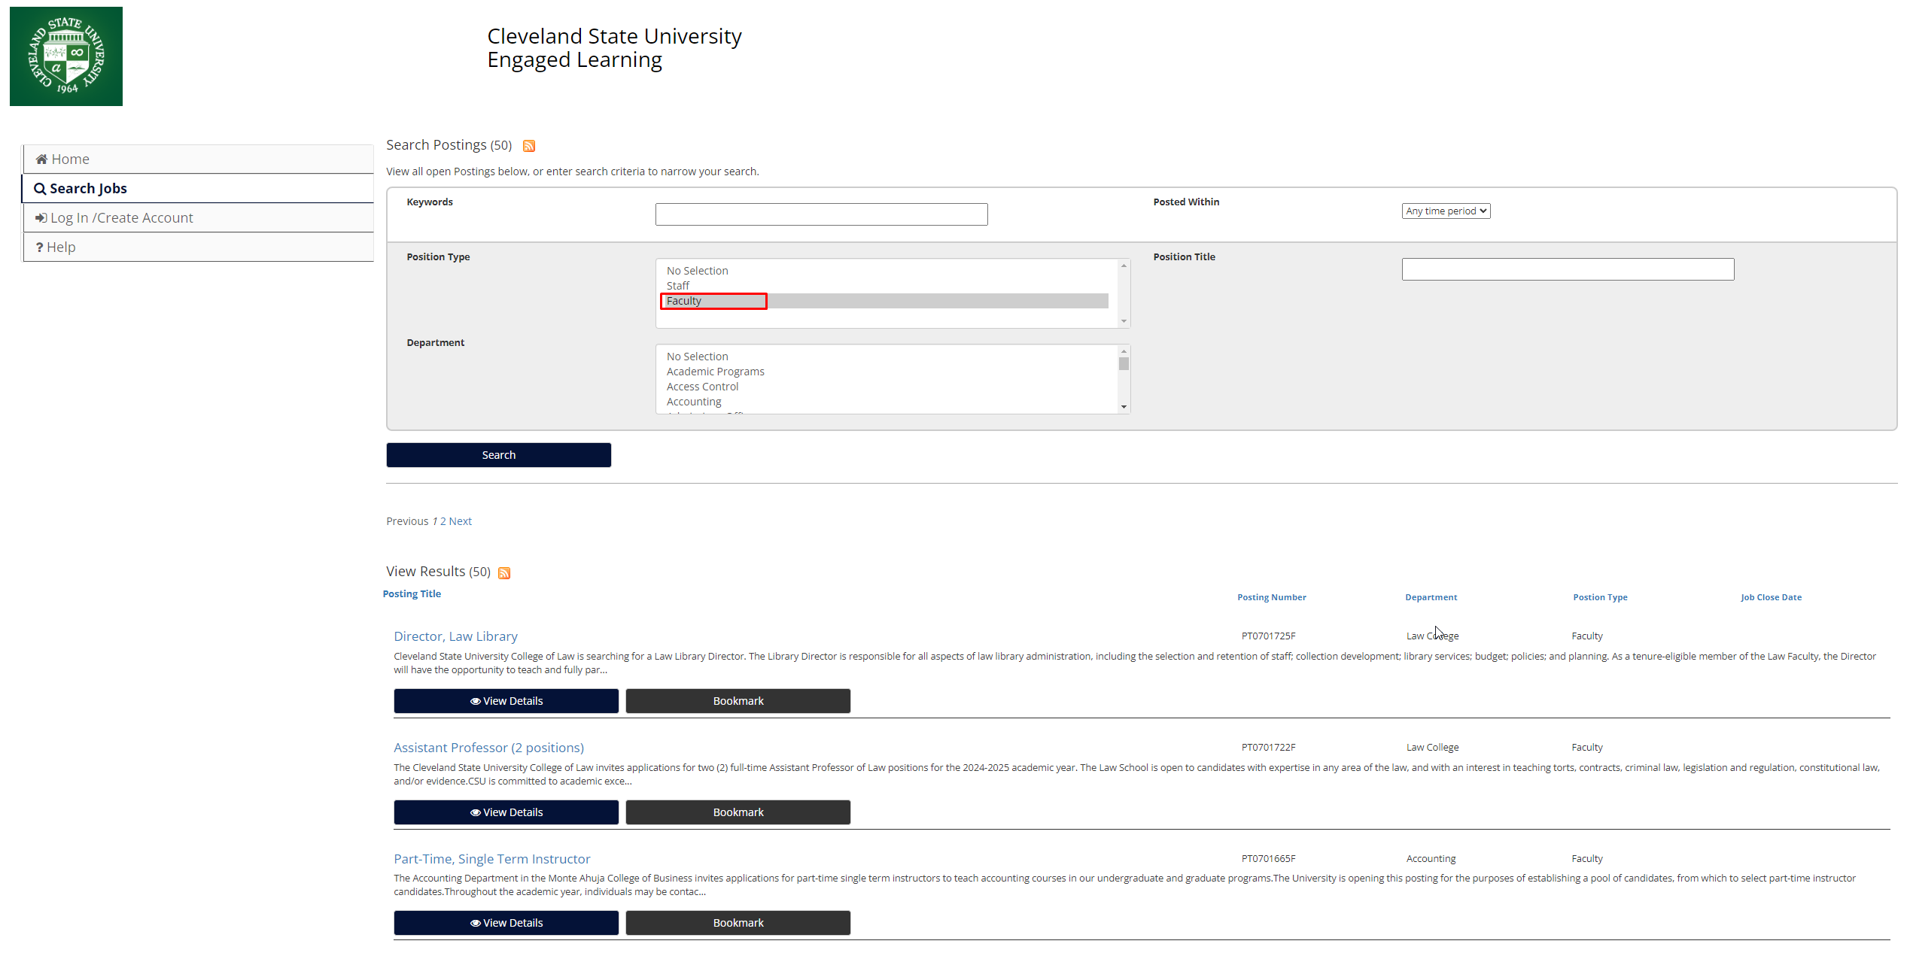

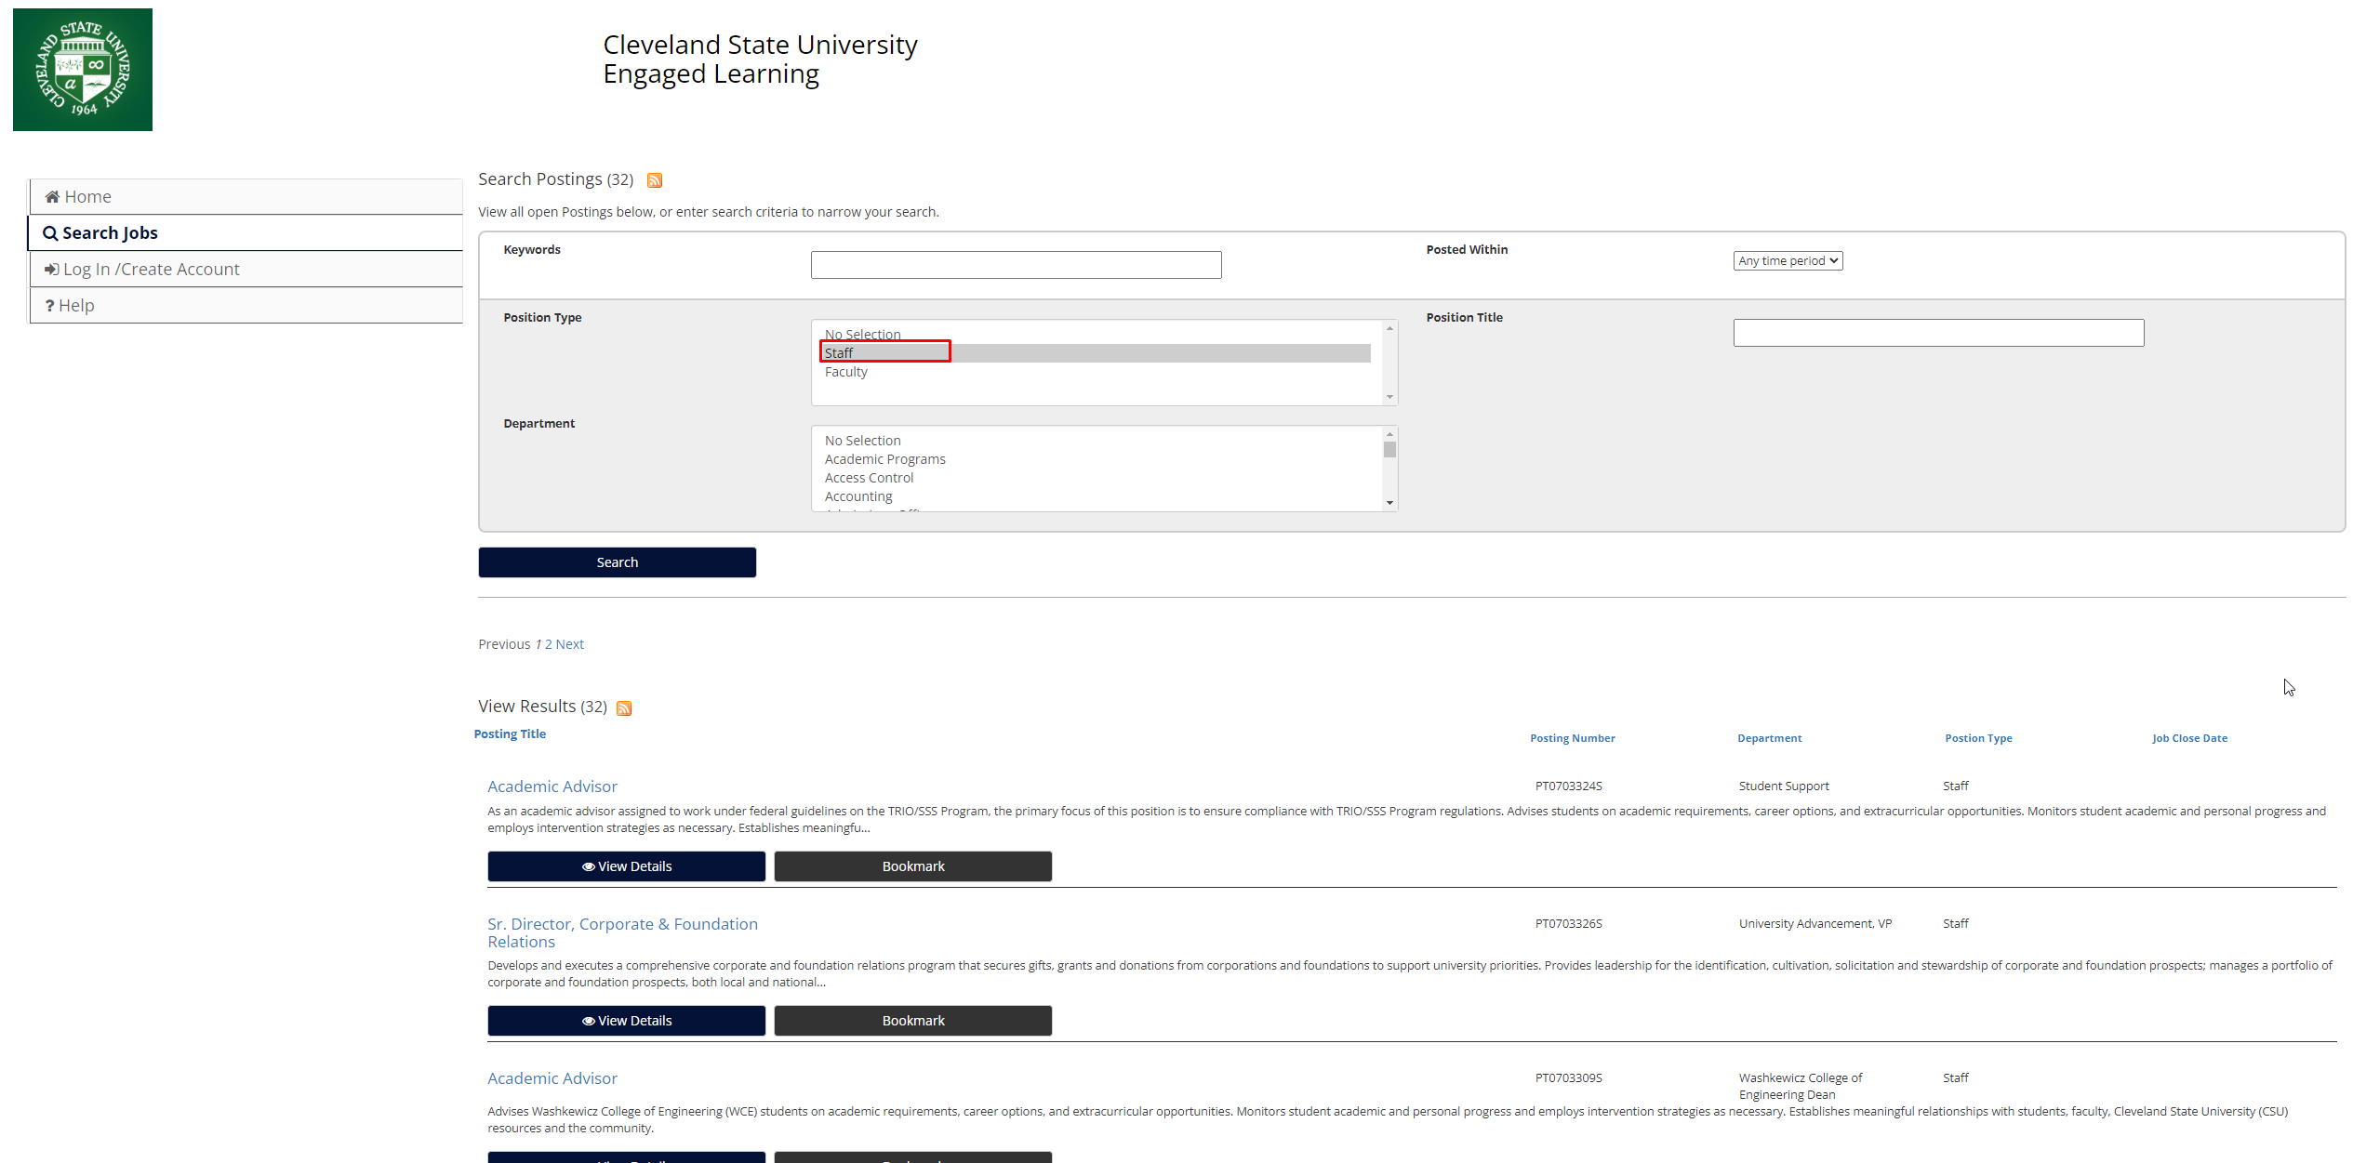

## **3.7 About:**

You can navigate through the HRM About Page to discover institutes mission statements, understand HRM's role, explore department functions understand the benefits and compensations as an employee. Also through this page you can have an idea about the HR partners that the institution is associated to. Additionally, the page provides an overview on the various teams of Cleveland State University involved in various training and development programs. Therefore, it provides an excellent preface to all navigating users to get acquainted with the brain and brawns of the institute. Following figure shows an overview of the about page.

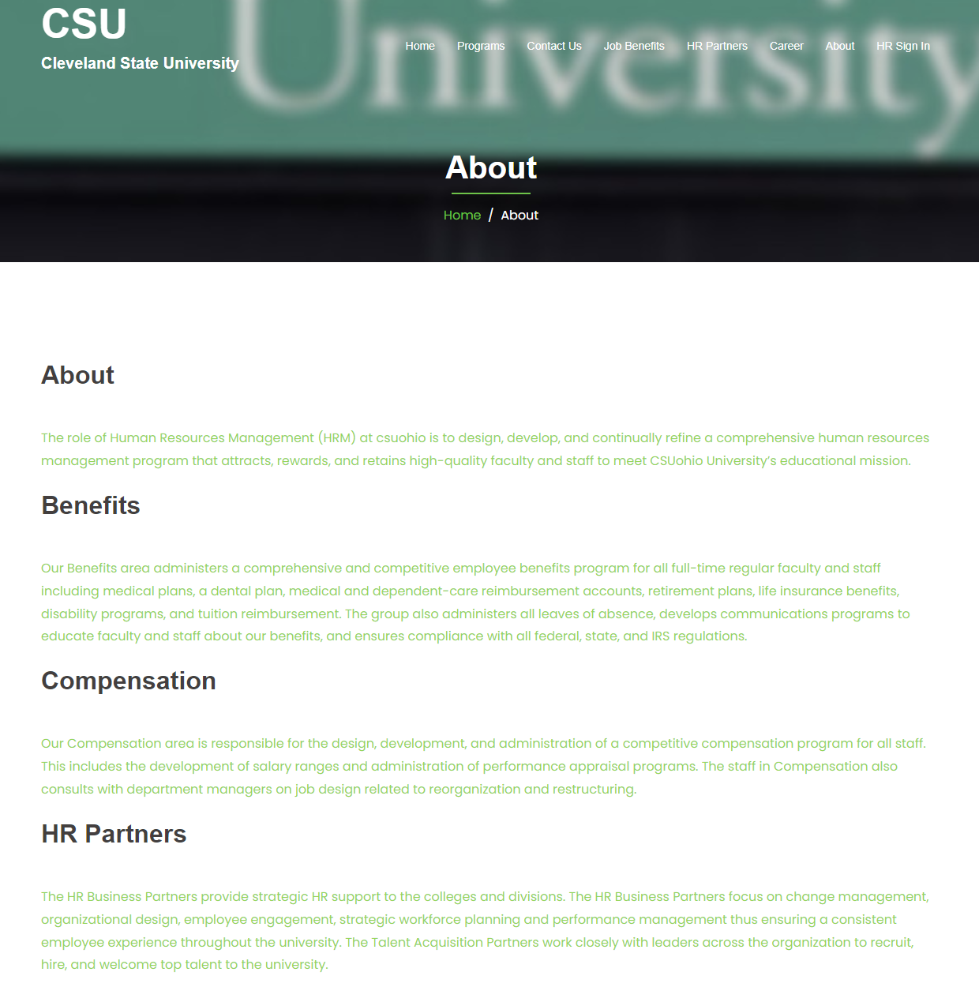

## 3.8 HR Sign in:

Last but not the least, the HR sign in offers direct access to the HR panel for the HR employees. If you are a user with proper credentials with HR access, you use your credentials to login to HR panel.

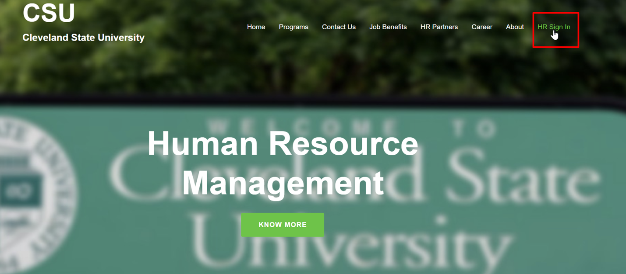

More details on this can be found in the following segment that discusses about admin panel.

# 4.0 Accessing the Admin Panel

Allowed users: Admin, HR manager.

URL: <http://northeastern.rf.gd/admin/>

This link directs to the admin panel of HRM panel where admin can perform various functions as a super user. He can perform administrative functions such as add, modify delete users (HR manager or employees accounts). They can also create, modify or delete pages. Admin can also add, modify or remove development programs, training programs and access all the menu pages. If you have the valid credentials of an admin you can access using the above link and it will look like the following figure (access page for admins).

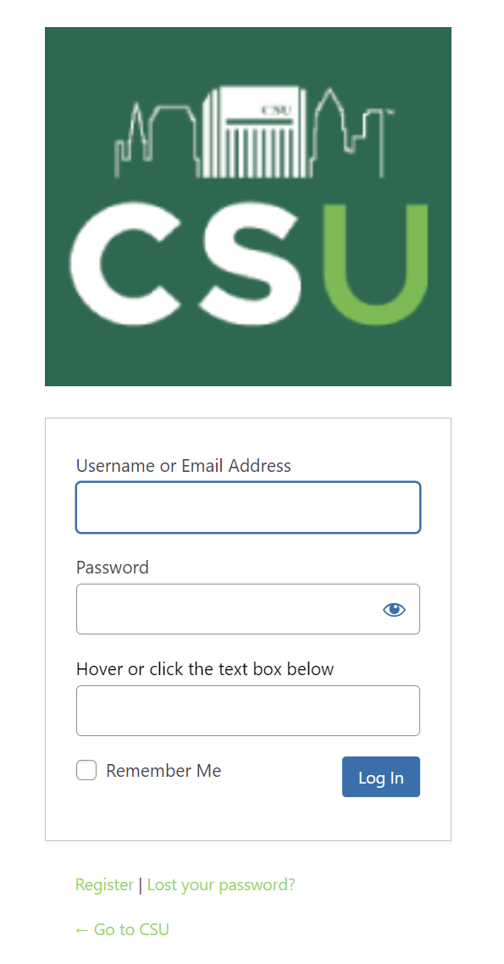

* **Login Credentials**: As mentioned previously if you have proper login credentials (in this case Admin) then please use your HRM ID and password to log in. Only Admins and HR managers can use proper credentials to access this page.

# 5.0 Dashboard Overview (Human Resource Management (HRM) Users)

The following segments and figures show general access steps for various pages and functionalities. All of the images for major functionalities are provided in the previous segments while a more condensed version is given below.

* **Accessing Dashboard:** Navigate to HR sign-in.



* **Homepage**: Quick overview of key metrics, notifications, and pending tasks.
* **Menu Navigation**: Sidebar navigation through Employee Management, Performance, Talent Acquisition, Payroll, and Benefits, Professional Development, Leadership Training programs, Team Development Tool, and Careers Portal.
* **Add Pages**: Dashboard > Pages > Add Pages > Click on Submit when done
* **Edit Pages**: Dashboard > Pages > All Pages > Click on Edit
* **Add Events**: Dashboard > Events > All Events > Add Events > Select Date and fill in all the required fields to display events.
* **Add Users**: Dashboard > Add New Users > Fill all fields > Select role > submit to add users.
* **Display all Users**: Dashboard > All Users

The following figure shows the major functionalities of the admin pane. Highlight 1 manages events (add, modify or delete), Highlight 2 manages pages, Highlight 3 manages Teams and Highlight 4 manages user.

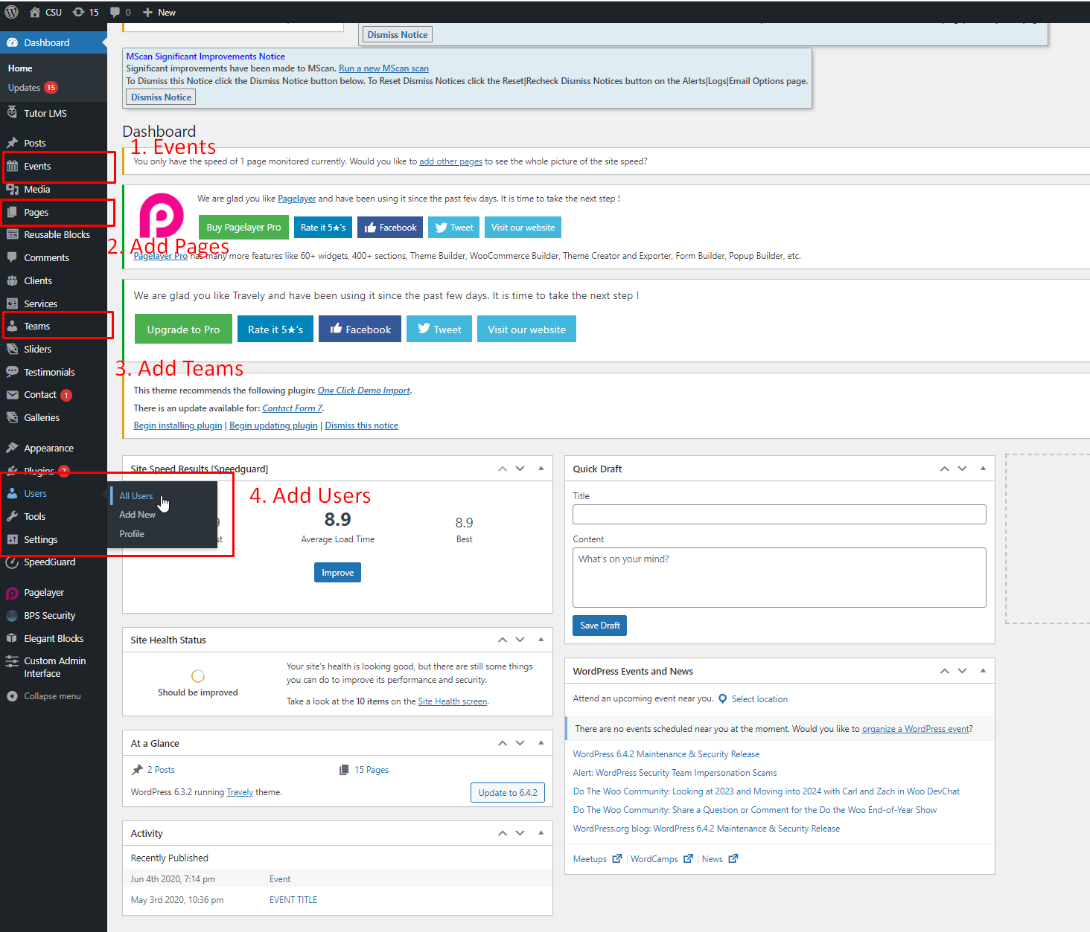

## 5.1 Professional Development Interface (End Users or Employees)

* **Accessing Program**: Navigate to Professional Development > Sign in > View video.
* **Event Calendars Integration**: View and manage upcoming events and training sessions.
* **Online Registration**: Register for the professional development program if not registered.
* **Participation Tracking**: Track progress by clicking the complete course button.

## 5.2 Leadership Training Module (End Users or Employees)

* **Enrollment**: Enroll in leadership training under Leadership Training > Sign in > View video.
* **Interactive Modules**: Engage with comprehensive, interactive training modules.
* **Online Registration**: Register for the professional development program if not registered.
* **Tracking Progress**: Track progress by clicking the complete course button.

## 5.3 Team Development Tools (End Users or Employees)

* **Enrollment**: Enroll in leadership training under Team Development Tools > Sign in > View video.
* **Interactive Modules**: Engage with comprehensive, interactive training modules.
* **Online Registration**: Register for the Team Development Tools if not registered.
* **Tracking Progress**: Track progress by clicking the complete course button.

## 5.4 Careers Portal (End Users or Employees)

* **Job Postings**: Access job postings under Careers Portal > Click on Faculty Positions or Staff Positions.
* **Resume Submission**: Submit and manage your resume for job applications.
* **Application Tracking**: Track the status of your job applications.
* **Streamlined Hiring Processes**: Experience an integrated approach to hiring, from posting to hiring decisions.

## 5.5 Managing Employee Data

**Adding New Employees**

1. **Navigation**: Employee Management > Add New Employee.
2. **Data Entry**: Fill in personal information, job details.
3. **Confirmation**: Review and confirm the information.

**Viewing and Editing Employee Profiles**

1. **Search**: Find an employee via the search bar.
2. **Edit Profile**: Select 'Edit' on the employee's profile.

**Performance Evaluation and Management**

* **Conducting Evaluations**: Performance > Evaluate Employee.
* **Accessing Reports**: Performance > Reports.

## 5.6 Talent Acquisition and Onboarding

**Job Posting**

1. **Post a Job**: Talent Acquisition > Post Job.
2. **Manage Applications**: Review applications.

**Onboarding Process**

1. **Initiate Onboarding**: Select a candidate and initiate onboarding.
2. **Onboarding Checklist**: Follow the checklist.

## 5.7 Payroll and Benefits Management

* **Managing Payroll**: Payroll & Benefits > Process Payroll.
* **Benefits Administration**: Access benefits information under Benefits.

## 5.8 Compliance and Legal

* **Ensuring Compliance**: Resources and tools under Compliance.
* **Legal Resources**: Access legal documents and guidelines.

## 5.9 Troubleshooting and Support

**Common Issues**

* **Login Problems**: Check credentials or reset password.
* **Access Issues**: Contact the cloud provider Infinity Free to upgrade it to premium for unlimited bandwidth.

**Contacting Support**

* **Support Desk**: Head to /contact-us/ for more information.
* **HR Queries**: Head to /contact-us/ for more information and submit an online form.

# 6.0 Conclusion

This manual tries provides an overview of the HRM Panel functionalities for the version HRM panel for CSU 1.0. Please be aware that many of the features might be absent, invalid or non-responsive for future iterations of the panel. For more detailed procedures or specific queries, please refer to the online help resources or contact the support team through contacts us page. If you encounter any bugs and have any suggestions for improvements, you are always welcome. Please send us mail at [dipenbhuva111@gmail.com](mailto:dipenbhuva111@gmail.com).